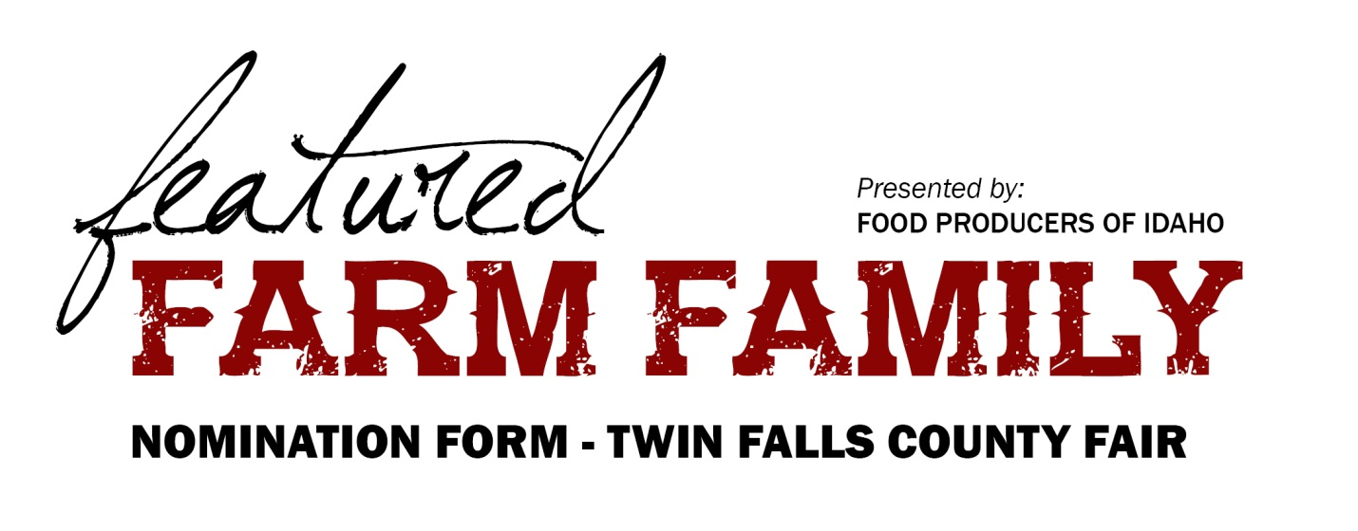
Name
Farm Name
Address
City/State/Zip
Phone
Email
How long has this family farmed?

- What commodities do they raise?

- What has most impressed you about their farm stewardship?

- How are they making an economic impact in their community?

- What innovative farming techniques or unique implementations have they used in their farm practices?

- List their community involvement (school activities, church, civic organizations, volunteer efforts, etc.)

- List one or two significant reasons why this family deserves this award.

NOTE: Please use additional pages if necessary.

Please complete and return by Friday, AUGUST 18, 2023 to:
Food Producers of Idaho
55 SW 5th Avenue, Suite 100
Meridian, ID 83642
Fax: 208-888-4586

FP/AgPav/Farm Families/nomination form

